

**This is a Sample Abstract Title**

**Author Name*, Author Name**, initials then surnames, separated by commas, appear here**

**This is a Sample Abstract Title**

*This is the corresponding author’s address, email address

**This is the second author’s address, email address

**Keywords**: Minimum 2 and up to 5 keywords separated by; semi-colons

**Abstract:** A short clear description of the main facts or ideas of your (outline) paper. This summary should not exceed 10 lines and should be inserted in the field on the first page in the area titled Abstract.

**Introduction:**

This is the first paragraph – text set with no indent but justified. This is our preferred style for all first paragraphs after headings. [12pt Calibri]. This is the first paragraph – text set with no indent. This is our preferred style for all first paragraphs after headings. [12pt Calibri]. The outline paper is limited to 1,000 words (max. two A4 pages with diagrams or illustrations).

All subsequent paragraphs are indented and justified. Your submission should include the background and nature of the issue or problem, your findings and results, and the significance and impact of your presentation on the topic of the conference.

**Methodology:**

A brief description of the methodology.

**Findings/Results:**

Summarise results and outcomes.

**Conclusions/Key Messages:**

A concise summary of conclusions/findings or learnings.

**Figures and Tables**

Figures and tables, both of which must have numbers and captions, either embedded within pages or at the end of the abstract.

*Table 1: Example of a Table*

|  |  |  |
| --- | --- | --- |
| **Heading 1** | **Heading 2** | **Heading 3** |
| Entry 1 | Entry 2 | Entry 3 |

**Figure 1.1** This is a style for Figure legends. “Figure 1.1, 1.2 etc” should be in bold. Figure legends should appear **below** figures.

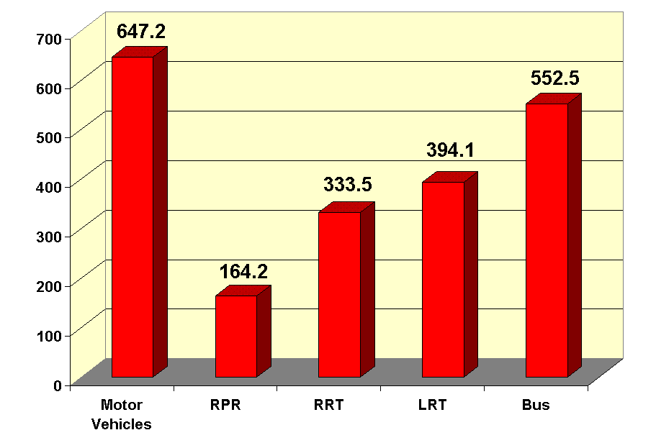

*Figure 1: Example of a Figure*

**References:**

**Journal:** Robson, A.J., Jones, T.A. & Reed, D.W. 1998 A study of national trend and variation in UK floods. *Int. J. Climatol*, pp. 165–182.

**Book:** McIntosh, A.C. 2003 *Asian Water Supplies.* IWA Publishing, London.

**Edited book:** Yoshida, Z. 1963 Physical properties of *snow*. In: *Ice and Snow* (W. Kingery, ed.). MIT Press, Cambridge, Massachusetts, USA, pp. 124–148.

**Report**: WWC 2000 *A Water Secure World: Vision for Water, Life, and the Environment.* Report of the World Water Council. World Water Council, Paris, pp. 120–140.